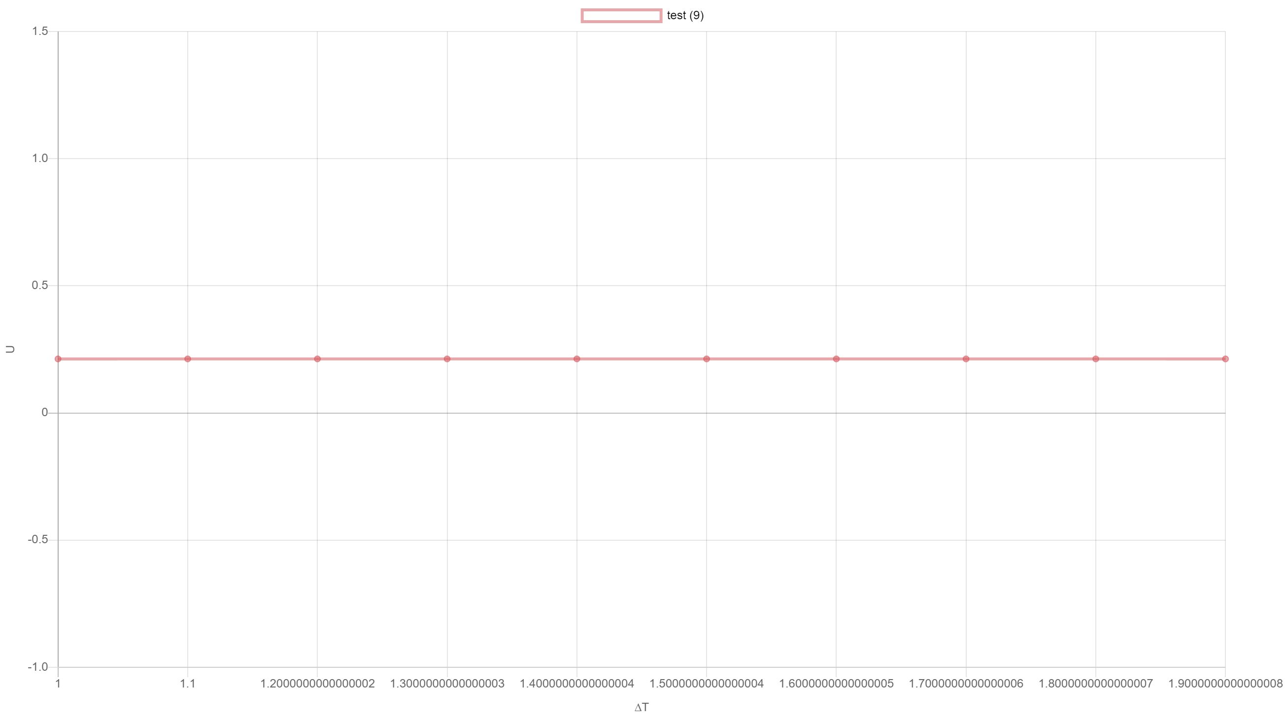

1. test (9)

|  |  |  |
| --- | --- | --- |
|  | **∆T** | **U** |
|  | 1 | 0.2124999999999999 |
|  | 1.1 | 0.2124999999999999 |
|  | 1.2000000000000002 | 0.2124999999999999 |
|  | 1.3000000000000003 | 0.2124999999999999 |
|  | 1.4000000000000004 | 0.2124999999999999 |
|  | 1.5000000000000004 | 0.2124999999999999 |
|  | 1.6000000000000005 | 0.2124999999999999 |
|  | 1.7000000000000006 | 0.2124999999999999 |
|  | 1.8000000000000007 | 0.2124999999999999 |
|  | 1.9000000000000008 | 0.2124999999999999 |